DIPARTIMENTO DI INGEGNERIA CIVILE E AMBIENTALE

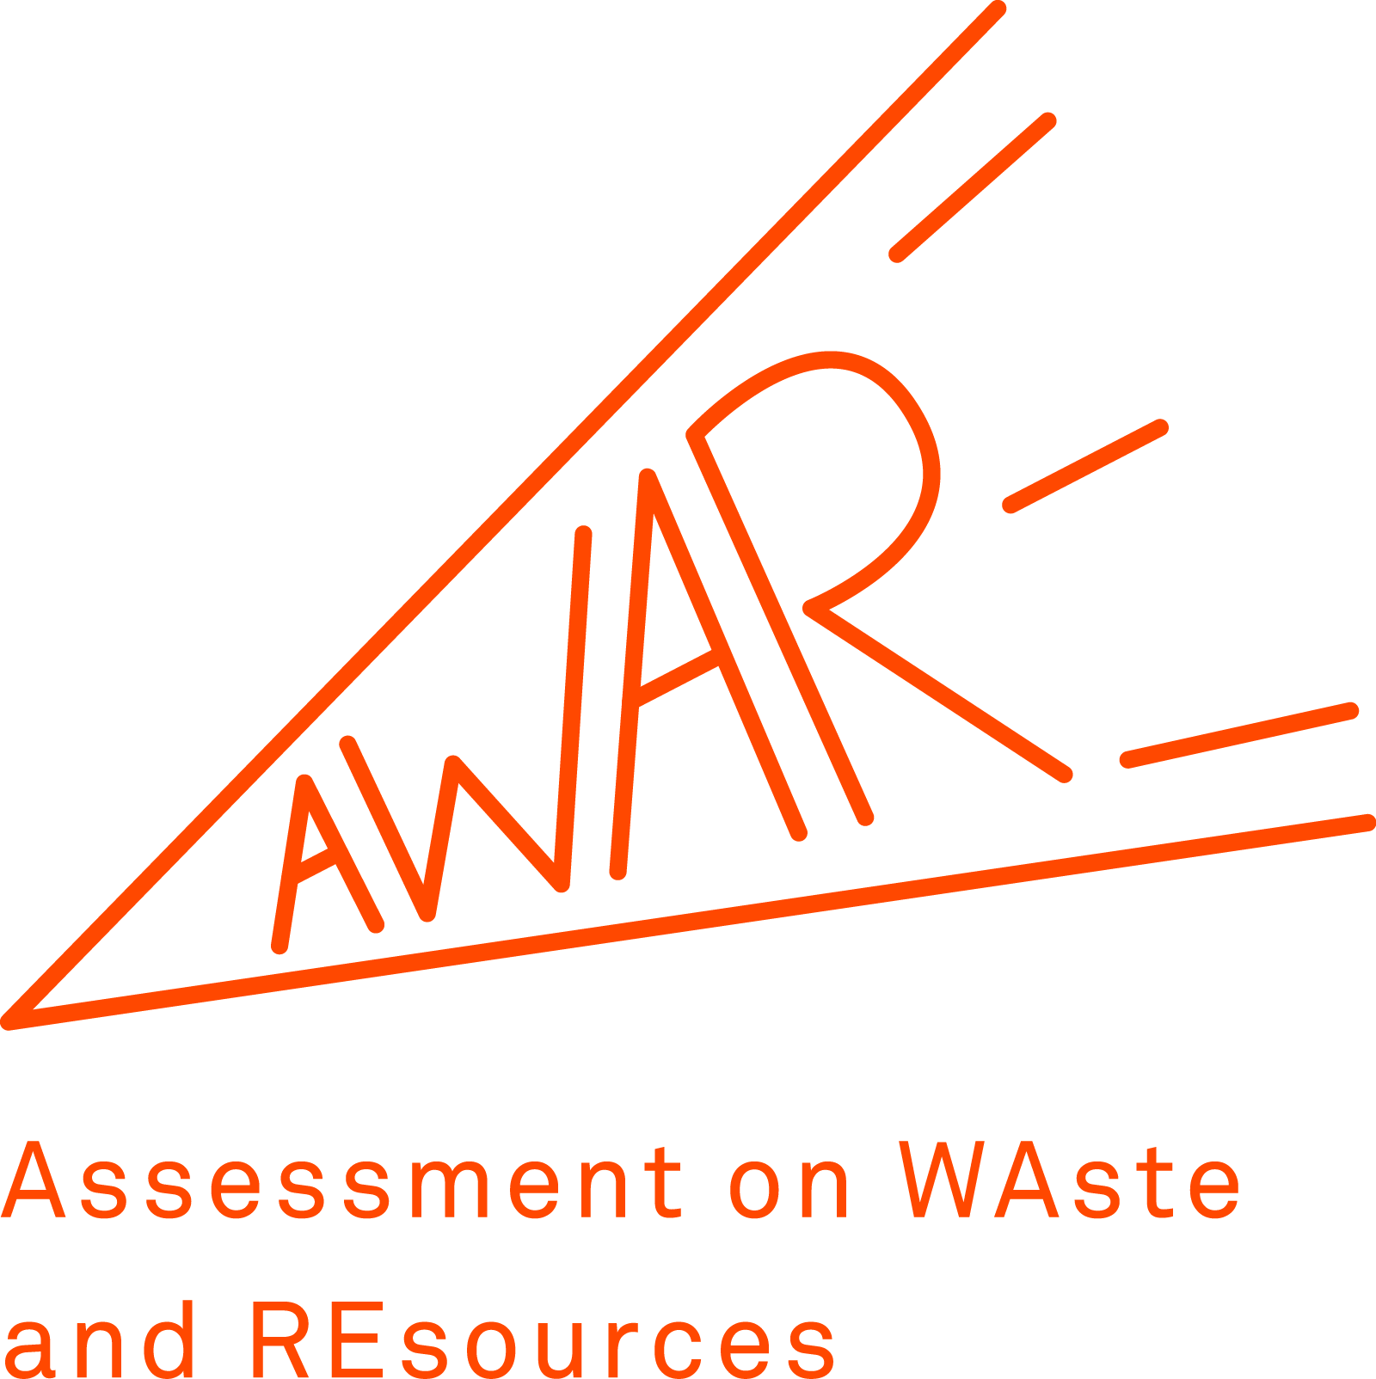

SEMINAR ANNOUNCEMENT

17th January 2019 – 14:30-17:00
Aula Bianca, Building 21, 6th floor
Department of Civil and Environmental Engineering

SUSTAINABILITY ASSESSMENT SUPPORTING CIRCULAR ECONOMY SOLUTIONS

Dr. Davide TONINI
European Commission – Joint Research Centre (JRC)

Abstract
The assessment of circular economy solutions require a holistic approach to avoid trade-offs between sectors or unintended environmental impacts. In this respect, life cycle assessments, costing as well as other life cycle based indicators are useful tools to support environmental sound decisions and policies. In this seminar, we will illustrate the on-going research and activities on sustainability assessment carried out at JRC. In particular, the focus will be on three major activities: i) Repair H2020 project (circular economy in peri-urban EU areas; focus on food waste), ii) organic fertilisers, and iii) alternative feedstock for plastics.

Bio-sketch
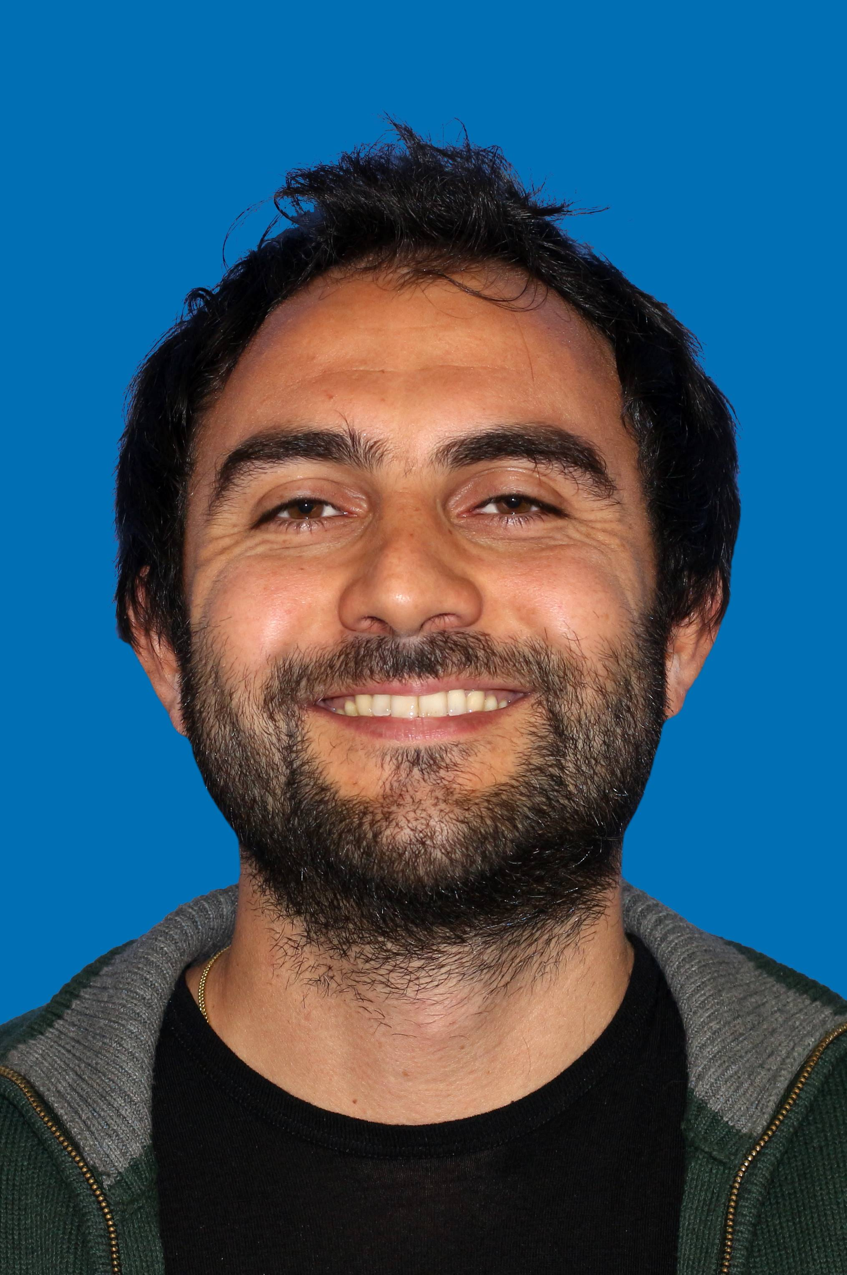
Dr. Davide Tonini
Environmental engineer graduated at Università di Padova, he holds a PhD in Life Science from Technical University of Denmark (DTU; 2012). From 2012 to 2017 he worked as researcher at Technical University of Denmark. He is currently Scientific Policy Officer at the European Commission Joint Research Centre in Seville (Spain), where his major research interests involve the development and application of different sustainability assessment tools to evaluate circular- and bio-economy solutions in the endeavor to support environmental sound EU strategies and policies.

